**Hotel Booking Demand**

**Introduction**

The hotel booking industry is growing rapidly throughout the years. From $466B in 2014 it grew to around $600M in 2018 (Source 1) and it doesn’t appear to slow down (well, given that there isn’t a global pandemic running around outside ☺).  
More and more mobile companies are basing their prime business on helping users to order a vacation to their favorite hotel in just a few clicks, companies such as AirBnB, Booking.com, Hotels.com, and many more, grant the user these possibilities today.

Because of the fact booking a hotel got much easier, hotels themselves need to relate to data a lot more than what they used to. They need to monitor how many orders they got and from which source, are they prepare for the amount of people ordering, what will be the expected number of people that would want to order next month, where does their hotel ranked in relation to other hotels, and much more.

Hotels, as many other fields today, need data to help them optimize.

On my project, I will take on a dataset related to hotels booking demand, to try and answer some of the questions below:

* What are the busy months people book a room in?
* How much time on advance, on average, people book a room?
* Which sources (Travel Agents/ Direct order) do people tend to book from?
* How much do guests pay for a room per night?
* How long do people stay at the hotels?
* Which month have the highest number of cancelations?

But our main question we want to answer regarding this dataset, from a Data Science challenge point of view is:

**What is the probability a booking will be cancelled?**

I think this is a highly important question to answer, since the hotel would want to know what is the expected number of people that will **actually** arrive from the people that ordered, so they will be able to prepare in the accommodation aspect – beverages and food amount needed, number of employees needed to be recruit to support the number of guests, maybe in terms of monetization, if there’s a high probability of cancelling a booking, the hotel can offer a better price for that person to insure that person will eventually arrive.

I believe is a large added-value to this work – giving hotels the ability to know this probability, from the reasons recapped earlier – if people have easier life to order, the number of cancellations will be larger than the past, prior the digital world.

The outcome, as I see it, will be defined as a number from 0 to 1, for each order, indicating the probability for it to be cancelled (1 means high chance of cancellation).

**Methodology**

**Data**

The data that will be used is extract from a Kaggle competition page (Source 2).  
This data describes two datasets with hotel demand data. One of the hotels (H1) is a resort hotel and the other is a city hotel (H2). Both datasets share the same structure, with 32 variables describing the 40,060 observations of H1 and 79,330 observations of H2. Each observation represents a hotel booking. Both datasets comprehend bookings due to arrive between the 1st of July of 2015 and the 31st of August 2017, including bookings that effectively arrived and bookings that were canceled. Since this is hotel real data, all data elements pertaining hotel or costumer identification were deleted.

Since we would like to test our model to see its performance, we will make a 80-20% split, so that the train data set will get 80% of observations and the test data set will get 20% of the observations.

Since we are not treating it as a time-series prediction problem, we do not intent to split the data by time frame of dates, but just randomize the observations without relating to the date factor.

Our “subjects”, or, observations, in this context are the bookings. Each row in our dataset represents a booking that was made to one of the hotels, and obviously they are aimed to represent a person that made this booking, but if a user made two bookings, there will be two different rows. Therefore, bookings are tagged as our subjects.

At the moment, there is no exclusion criteria. Maybe after our EDA we will find some outliers that shouldn’t be included, but currently, in terms of the business question, I don’t see a point to exclude some of the bookings.

My outcome variable, which I will based on my model, will be Reservation Status, which takes two values – “Check-In” and “Canceled”. Based on this variable we will be able to create our classifier.

In terms of confounding variables, I believe weather will have a large effect on whether people will cancel their booking, if there are seasons which tend to be uncertain in terms of rain or sun, there will probably be more cancellations in these periods.

Sources of bias might occur due to competitors – for example if in a certain period one of the hotel’s competitors went out with a better deal than what the examined hotel is offering, there might be more cancellations. Also, change of cancellations fee over time might cause a change in the cancellation probability – if the fee went higher, there probably be less cancellations. And of course, related to our lives today, if there is a global pandemic, we might see cancellation rate spikes due to that, so let’s put global phenomenon into the mix of bias sources that might effect the dependent variable.

My data exploration strategy will consist of first understanding the connection between the variables. The main questions we will try to answer are the ones explained on the Introduction section, and through that examination, I will probably find extreme values, missing cells and other abnormalities records. Through these questions, I will better understand how to model my algorithm, in the sense of which variables are more important, variables that effect the probability for a booking to be cancelled can be inspected by plotting the dependent variable against each of the candidate features and for those we see a correlation, might be helpful in our final model.

In order to enrich the data, if needed, we can create new clustering variables that group together values that show common behavior. For example, if needed, classifying type of bookings by the average daily rate to “high valued guests” and “low valued guests” and such.

For outliers handling, we will remove for example observations that fall into a low-frequency bucket, since they probably won’t help us so much. For example, if there are 10 room types, but one of the room types have a very low frequency, we might want to insert a NULL value there, and afterwards when we’re filling the missing values, we will impute the column’s mode into that observation. On the continuous case, we would like to remove users with very high values for some variables, such as people with a large number of visits in the hotel – they probably won’t be representative very much for the entire data set, therefore should be removed.

We will deal with missing values depending on the variable type. If the variable is categorical, we will impute the missing values with the mode of the column, and if the variable is continuous, we will fill it with the column mean.

**Model**

I am planning on dividing the data randomly across all bookings, I will take 70% of the data as training data, 15% for validation and 15% for the test dataset.

In our dataset, 37% of the overall records are tagged as “Cancelled”. Therefore, I don’t believe there’s a need to balance the dataset, since we have good proportions of each class so we don’t need to use techniques of under/over sampling.

This is a Classification task, therefore the techniques and algorithms I will use will be centered in classification algorithms.

In order to find the optimal parameters for the suggested models, I will use cross validation to evaluate the test error.

The measures I will use to evaluate my model are centered around the classification error.

The classic loss function for this kind of tasks is **cross-entropy**, since it measures the loss where there are 2 or more classes.   
I will also use metrics based on the confusion matrix, like **F1 score**, which is a measure of the model accuracy. It is calculated from the precision and recall of the model, where the precision is the number of correctly identified positive results (in our case – cancellations), divided by the number of all positive predicted results, and the recall is the number of correctly identified positive results, divided by the number of all samples that should have been identified as positive.

In terms of ensemble, I will have to see what the models results show, if a certain model shows complete dominance over the others, I don’t think an ensemble model is appropriate, I will just use this one single model. If several models are close, and they are better than each other of different aspects of the quality measurements, then I will try using an ensemble model.

**Deployment of the model**

The QA to my model will be made by the personnel in charge of the bookings in the hotel.

First and foremost, the validity of the data is highly important, therefore they need to go through the different bookings and assert that the booking that were tagged as cancelled, did actually were cancelled.

Based on the valid data, the model will be run and produce an output in the form of a probability. The QA part in this context is to inspect the given probability and to try and figure out if there are not any weird behaviors.

Weird behaviors can be classified as technical issues and business issues.

Technical issues can be emerged by null predictions, probabilities that are above 1 or below 0, etc.

Business issues can be expressed by tagging guests that are known to arrive as high probability for their booking to be cancelled, or that the model produces too many expected cancellations, for example if the overall cancellation rate is around 35%, if the model produces a relatively higher proportion of cancellation in comparison to that number, there might be a problem in the model.

The business issues can be checked by making a “sanity check”, meaning taking a few cases and observed the behavior of the model upon each of the cases. The QA here needs to use his previous knowledge of the business, he knows best what does and what does not make sense regarding cancellations. This is not the position of the Data Scientist, in my context as sort of a free-lancer, to know these issues. That is why QA work and DS work complete each other.

Finally, for cases that the QA is not so sure about and there is sort of a disagreement between what the QA think compared to what the model thinks that will happen, they might want to keep that record for later to inspect if the model was actually right. They will do this by waiting for the actual time for the guest to arrive, so most cases we would want to pick bookings that the guests are about to arrive in the near future, so we won’t have to wait that long to see if the model was right or wrong. The QA would want to know as soon as possible if the model is wrong, so a change in the model can be made and the hotel won’t rely on a wrong prediction.

The QA Protocol:

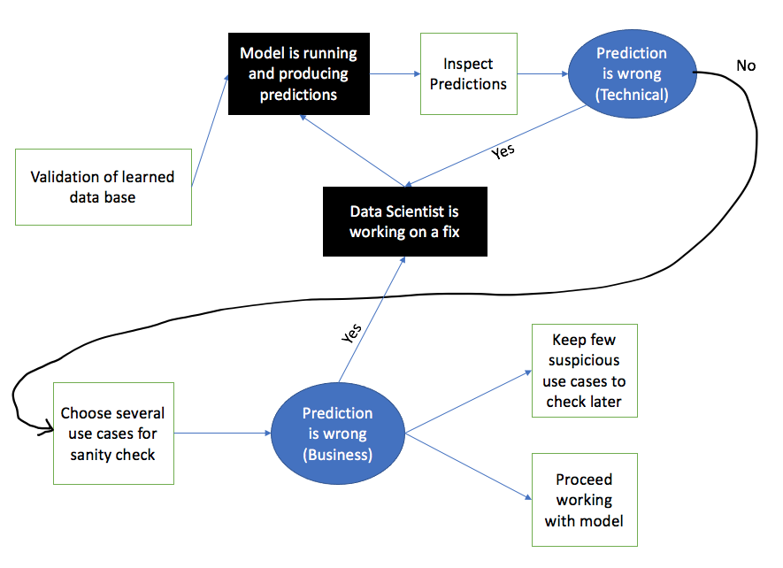

The QA protocol above demonstrate the sequence of events as I’ve described above. The black boxes are literally black boxes from the QA perspective. The QA doesn’t care about what is going on in these processes, they are just reviewing their output. This is mainly just the Data Science work to make these black boxes useful. The other boxes a pretty much self-explanatory, attaching the explanation prior the photo.

The final user of the predictions is the hotel managers. They are the ones that need to know how many guests are expected to arrive, due to reason I already explained in prior chapters (manpower, food supply, etc.).

The hotel managers will be trained to use the output of the model as treating it as a score – the higher the score is, the higher the chances this booking will be cancelled.

They will be taught that summing the prediction column for a given date, will produce the average number of cancellations they will have on that day, and dividing that sum by the total number of bookings will give them the ratio of expected cancellations out of the total bookings on that day.

The black boxes on the photo above are generally R scripts that take the input data and produce predictions, so the platform of deployment is R. The code will be on the Cloud, so that an automatic process will be able to reach the code and update the predictions online.

The model will be updated each day, since each day there are new bookings to be predicted.

In cases where the model returns a null prediction, as I’ve mentioned on the QA part, it is classified as a technical issue that needs to be handled. The easiest solution for null predictions is to impute them with 0, but this is not the optimal solution in this context. The model should be reverted back, and the Data Scientist needs to work on fixing that issue.

The measurements that will be used to evaluate if the prediction performance is decaying will be our error scores specified on last chapter – the cross-entropy loss and the F1 score. The main problem here is that we only know that in retrospective, but we will probably try to test this on bookings that their arrival date is near, so we will be able to get a grasp on the accuracy of the model quickly.

The prediction will be adapted be the final user (the hotel manager) in a way where they will decide what is the threshold, they would want to treat a booking as a high chance of cancellation. They might want to be conservative, and then they will treat even 30% chance of cancellation as a serious case, or they might want to be more loose and then treat only 60% chance as a case that needed to pay attention to.

**Results**

**EDA**:

In order to find a proper model for our dataset, first we need to understand the data, how it behaves, what correlations do we have with our outcome variable and get a grasp on the nature of the bookings in general – when are there more cancellations, and what conditions etc.

First, let’s review the hotels daily orders:

As we can see, there are some extreme values, and it looks like up until mid-2015, the hotel was not very active, with very low number of daily orders.

So the first thing we will do, is exclude the period where the hotel only got started, up until mid 2015. I still don’t want to exclude the days with extreme values, since they can be meaningful in the future.

To get the actual trend without the extreme values messing up the visualization, let’s look at both hotel type’s running average trends:

There is a clear distinction between the demand of then City hotel and the Resort hotel, as we see that the demand on the City hotel is twice as large as the demand on the Resort hotel.

We can also see that the extreme values are only related to the City hotel, there aren’t looking to be extreme in the Resort hotel data – a stronger indication why we should keep the extreme values – they are meaningful.

Let’s try to drill-down a bit further in this visualization and try to relate the behavior to cancellations.

Above, each square is related to a different hotel type, and the colors indicating the daily trend of cancelled and non-cancelled bookings.

As we can see, the Resort hotel, although being less attractive in terms of daily bookings, has a more stable behavior. The cancellations there are not that drastic and the smoothing average of the cancellations almost never surpasses the smoothing average of the non-cancellations.

On the City hotel, on the other hand, there are a lot of cancellations spikes, at the start of the hotel’s opening in 2015-2016, and a spike near the start of 2017.

Therefore, based on this behavior, a feature that indicates the **hotel type** will absolutely be an essential part of our final model.

Now let’s try to review the data by a season classification, to see if bookings tend to be cancelled more in wintertime rather than summertime, for example:

We see that in the City hotel, winter times do get higher cancellation ratios, but for the Resort hotel it doesn’t look like there’s a seasonal effect.

Another important feature that I had in mind that can be important is the lead time – that is, the number of days before arrival the order was made.

Above we can see that the lead time is a variable which has a long-tailed distribution, where most of the bookings lay at the small values. This means that most bookings are short-term – planning go to the vacation soon after the order was made.

By the way, this property suits our goals on estimating the performance of the model, since we would want to get the feedback on the model prediction as soon as possible.

Let’s divide this variable into buckets, to get a sense of whether there is a correlation between the lead time and the probability to cancel the vacation.

Here, we used k-means algorithm to divide the lead time continuous variable into 30 distinct buckets. I’ve filtered here buckets with more than 100 records, therefore there some missing observations on the Resort hotel dataset.

As we can see, there is a strong correlation between the number of days the order was made before arrival to the cancellation probability.

Small bucket values, which indicate small lead time values, mostly don’t get cancelled, whereas on the City hotel 75% of high value buckets, which translated to 300 or more days before arrival, are getting cancelled.

Once again, there is a big difference in behavior between the City and Resort hotels, as the Resort hotel tends to stabilize at some point, whereas the City hotel keeps on getting higher on cancellation values as a function of the lead time.

Next, we will try and investigate if the family combination that ordered the vacation effects on the probability to cancel:

Here we tried modelling the family combinations by “Adulst_Childern_Babies”.

It doesn’t seem like there’s a correlation, therefore we would not assume that the family combination matters in this context.

The next feature we would like to inspect is the vacation length, with the thought of longer vacations are maybe more committing and people will tend to arrive.